

Grid Capacity Review
Scrutiny Committee Task & Finish Group
Issues and questions tracker

Interpretive note: This is a living document, and during the duration of the review these questions and answers will be revised and refined. At any given point in time the answers provided will reflect the views of participants to date or any evidence reviewed to that point. As such, it is possible that further nuance may be added as the review progresses, and that contrary opinions may be expressed by later participants.

Primary issues:
This section provides an evolving and overarching statement of the issues to be explored, to guide and frame the line of questioning pursued.
[This statement of the primary issues was provided to help retain focus. It evolved as the sessions proceeded – but I’ve kept this early one in here to illustrate]
There are existing and forecast grid capacity constraints on both the distribution and transmission networks which can impair the ability to connect both new supply and demand, especially in those circumstances where the connection requires upgrades or ‘reinforcements’ to be made to the network. Transmission constraints are even inhibiting the possibility of some distributed connections until as late as 2036. The issue is less technical than economic: in principle anything could be connected, but the issue is that it is not always reasonably affordable or timely to do so.
Managing these constraints will require a mix of solutions, including:
- more strategic investment for grid upgrades, realised through better local evidence on need and stronger local governance
- innovative deployment of flexibility technologies
- national policy reforms, such as on connections pricing and queuing
A more strategic rather than reactive approach to investment is required. Costs for new connections could be cut significantly through more strategic investment to address constraints, rather than reacting piecemeal to individual connection requests. Network operators can seek approval from Ofgem to strategically invest based on forecast need. In principle they’re incentivised to do so, as they make money based upon how much infrastructure they own and operate (the more they build, the more income they can raise).
However, the challenge is to demonstrate need: making the case for investment to Ofgem currently requires a high level of certainty about a proposed project (‘we’ll do this, here, then, with this investment’), so network operators are very risk averse regarding stranded assets. But what councils can offer currently is less certain and detailed than what is required. In some cases this can even create a chicken and egg problem, where DNOs require something like specific connection requests or a pipeline of specific schemes to evidence need, but the development of such is itself inhibited by the presence of constraints.
Strategic energy planning will require a stronger evidence base and better clarity on local ambition. Enabling strategic investment will need to consider how to strengthen the evidence base on forecast supply (through clarity on local generation aspirations) and forecast demand (through clarifying aspirations on both new developments and retrofitting existing developments to electrify transport, heating and industry). These are the critical factors that will impact peak demand. Ideally network operators’ forecasting would be informed by a clear, locally developed pipeline of specific schemes for supply, demand and flexibility (such as defined through the production of a Local Area Energy Plan).
Additionally, a more strategic approach will require strengthened local governance with democratic input that likely require strengthened local governance with democratic input and which can develop a better approach to risk sharing and the risk profile of schemes.
Ultimately, network operators want to invest as it makes them money – the issue is how we can best support them to make the case for investment to Ofgem. Ofgem and DESNZ are keen for them to better reflect local need – but they need to be able to evidence such, by considering and clarifying the strength of local ambition on things like the pace and extent of renewable generation, building standards, retrofitting of the existing stock, and EV and low carbon heating deployment. Network operators are keen to move to a more strategic system, but the details of how to do so are to be worked out.

Questions tracker:
[This is illustrative of our early discussions, but likely generic enough to be applicable to your area too]
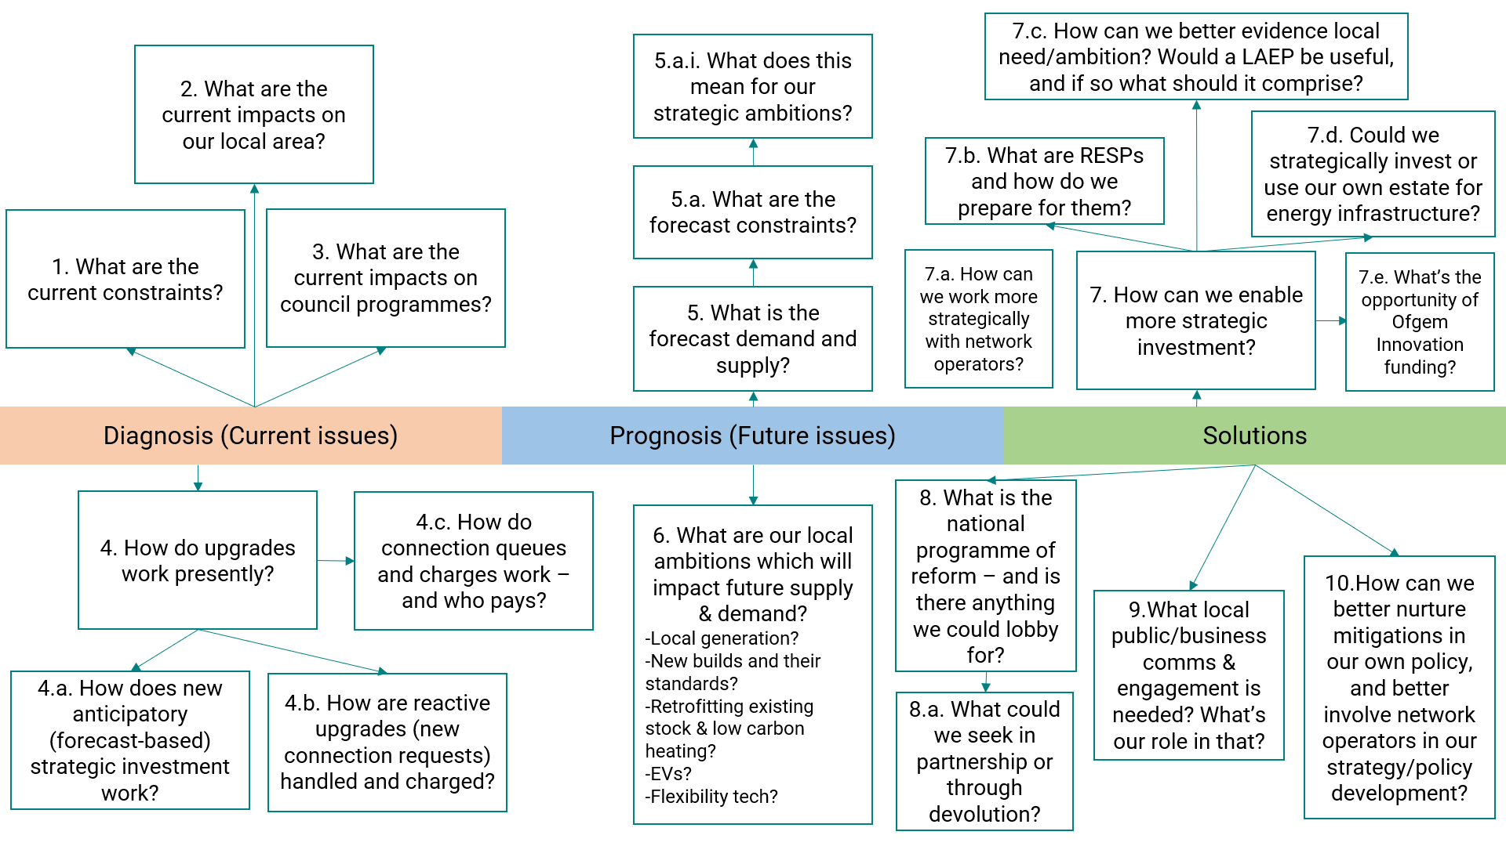
The current system (Diagnosis)
[The high-level questions here (in bold) correspond to the nodes in the diagram above – so again, they’re probably applicable to your areas. The questions nested below them (underlined) were those that emerged in discussion during session 1. I’ve kept those in, and the answer to the first question, just to illustrate how this was structured. Essentially this document is a rationally-reconstructed/structured set of minutes]
1. What current constraints are there locally?
What evidence is there on the shape of current distribution and transmission constraints in Dorset?
There are 3 Grid Supply Points (Axminster in the west, Chickrell near Weymouth, and Mannington out East), and that these are owned by National Grid Transmission. Three areas served by the three areas served by the respective Grid Supply Points, with the largest area being Mannington (covering the largest number of substations and customers).
SSEN is the Distribution Network Operator for most of Dorset, with a small section to the west controlled by National Grid Electricity Distribution (‘NGED’). The distribution network comprises 13 Bulk Supply Points and 53 Primary Substations. In addition to the lines and cables connecting them, this is much of what constitutes the network in Dorset – and much of whose capacity is at issue regarding constraints.
There are a suite of documents or sources of information that inform on constraints and their intent to address them. This centrally includes:
- Online heat maps ((www.network-maps.ssen.co.uk ; www.nationalgrid.co.uk/our-network/network-capacity-map-application) show where there’s currently headroom capacity, or where it’s limited or non-existent. These can help inform developers where connections are more or less likely to trigger reinforcements.
- Long-Term Development Statements are annual statements which give a rolling 0-5yr view, showing where is expected to reach capacity in the next 5 years. They’re published each November and updated each May.
- Distribution Future Energy Scenarios (as mentioned in Session 1) are annual, scenario-based, long-term projections to 2050 using four scenarios.
- RIIO-ED Business Plans (also mentioned in Session 1) are the investment proposals that have to be approved by Ofgem for each 5-year price control period (currently 2023-28).
- Network Development Plans incorporate all of those, but give a longer-term 10yr plan to address constraints. But they only show intent: they’re subject to the Ofgem’s agreement of the underlying Business Plans; and they can be modified if future forecasting justifies such.

Do we know how many buildings are served by each substation in order to determine the relative importance of different constraints?

Are there any other sources of delay beyond network capacity constraints?

Are there any delays on deployment owing to planning backlogs, and if so could low carbon infrastructure could be better prioritised in planning processes?

2. What are the current impacts on the county?
Is there evidence that development opportunities have already been lost due to existing constraints?
Have any planning applications been resubmitted since the changes to connection charges if made more viable?
What are the cost implications for development of securing extra capacity for heat pumps?
3. What are the current impact on council programmes?
What transport projects have been impacted?
What are the cost implications for the council of the failure to secure connections in a timely manner or at all?

4. How do upgrades work presently?
How are upgrades funded presently?
4a. How does anticipatory (forecast-based) strategic investment work?
What documents constitute the strategic investment case?
Is the 5-year timescale of strategic business planning long enough to be strategic?
What do network operators seek or require to justify strategic investment?
Where is current transmission network investment planned for?
Where is current distribution network investment planned for?
Are there any regional inequities in current or planned investment?
Do network operators assume that a lack of requests entails a lack of interest/need (with the risk of ignoring the possibility that developer knowledge of constraints disincentivises them from making requests in the first place)?
4b. How are reactive upgrades (new connection requests) handled and charged?
How do connection agreements and charges work?
Are connection agreements negotiated and can they be challenged?
How well do developers understand the charging regime?
Are there any regional inequities in connection charges?
How does connections queuing work and how has policy recently changed?
The Future System (Prognosis)
5. What is the forecast demand and supply?
What documents are most useful to consider on forecasting?
How does the council input into forecasting analysis?
5.a. What are the forecast constraints?
5.a.i. What does this mean for our strategic ambitions?
How could our future strategic objectives be impacted by constraints?
What is the expected economic impact for Dorset if constraints aren’t addressed?
6. What are our local ambitions which will impact future supply & demand?
What is Dorset’s renewable generation potential?
What are our ambitions for local renewable generation?
What are our ambitions for the extent, location and standards of new builds
What are our ambitions for the pace of retrofitting and low carbon heating deployment?
What are our ambitions for the pace of EV and EV charger deployment?
What are our ambitions for the deployment of flexibility technology?

Solutions (Treatment)
7. How can we enable more strategic grid investment?
How are other areas or countries tackling the issue?
7.a. How can we work more strategically with network operators?
Do we need to meet strategically regularly with network operators? Will that be fulfilled by the RESP, or do we need to go beyond that?
Are we providing sufficient input into DNO’s DFESs?
Are we facilitating sufficient influence of wider local stakeholders on DNOs and into the DFES – and do we even need to, or is that done by network operators’ engagement themselves?
Are there any collaborative projects or co-investments we could explore together?
7.b. What’s are RESPs and how can we best prepare for them?
What are Regional System Planners?
What is our view on our role with respect to Regional System Planners and their design?
How do we build knowledge and capacity for them internally, and best coordinate across teams so that our representatives can best participate?
What data gathering can we do in preparation?
How can we best articulate our asks to the RESP?
7.c. How can we better evidence local need?
What is Local Area Energy Planning and how are other areas approaching it?
Does the council need to understand and identify what upgrades are needed itself?
7.d. Could we council strategically invest ourselves or use our own estate for energy infrastructure?
7.e. What is the opportunity of Ofgem Innovation Funding?
What is Ofgem innovation funding?
What past projects have other local authorities done through the fund?
8. What national policy reform is needed that we could lobby for?
Are there any asks we need to make of Government or the Crown Estate?
Do we have any views on connections queuing or charging reform?
Do we think any changes to the national planning framework or building standards are needed?
What’s our view on community benefits?
8.a. What could we seek in partnership or through devolution?
How could lobbying be most effectively undertaken and what should we lobby for?
What are the opportunities of devolution?
What changes are we most interested in seeking?
9.What local public/business comms & engagement is needed?
Is there a need for comms to businesses or the general public?
10.How can we better nurture mitigations in our own policy and better involve network operators in our strategy/policy development?
Where does the grid, strategic energy planning and DNOs need to be better involved in council strategy and policy development?
What is the role of battery storage and other flexibility measures?
What is the potential of microgrids (like at Hazelmead)?
Could households be more self-sufficient using more solar PV and battery storage?

